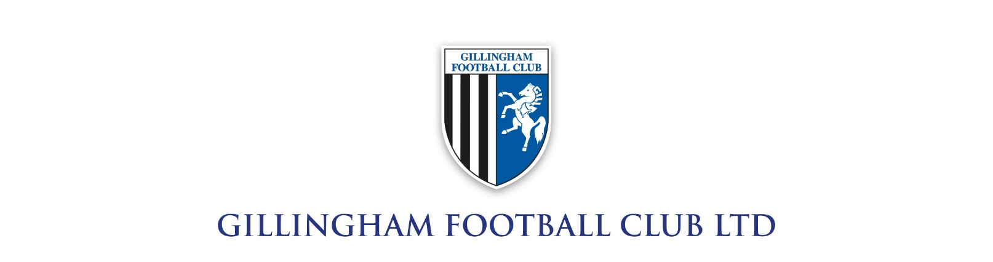
Job Title: Commercial Sales Executive (LED & Digital Advertising Focus)
Organisation: Gillingham Football Club
Location: Gillingham, Kent
Department: Commercial

Role Overview
Gillingham Football Club is seeking a driven and commercially minded Sales Executive to grow and deliver the club’s LED and digital advertising inventory. This role will play a key part in maximising matchday and non-matchday revenue, ensuring strong partnerships with local, regional, and national brands.
The successful candidate will be responsible for identifying new business opportunities, managing existing client relationships, and delivering innovative advertising solutions that enhance brand exposure and commercial return for our partners.

Key Responsibilities
- LED Advertising Sales
  - Proactively sell pitch-side LED advertising packages to new and existing clients
  - Develop tailored proposals to maximise client exposure across matchdays and club platforms
  - Achieve and exceed individual and departmental revenue targets
- Business Development
  - Build a strong pipeline through networking, outreach, and industry engagement
  - Attend events, matchdays, and networking opportunities to generate leads
- Account Management
  - Maintain and grow relationships with existing sponsors and advertisers
  - Ensure delivery of all LED advertising commitments and campaign objectives
  - Provide post-campaign reporting and insights to clients
- Collaboration
  - Work closely with marketing and media teams to optimise LED content and scheduling
  - Support broader commercial initiatives including sponsorships, hospitality, and partnerships
- Matchday Delivery
  - Be present on matchdays
  - Ensure seamless execution and client satisfaction

Key Skills & Experience
- Proven experience in sales, preferably within sports, media, or advertising
- Excellent communication, negotiation, and presentation skills
- Target-driven with a proactive and resilient approach
- Ability to build and maintain long-term client relationships
- Strong organisational skills and attention to detail

Personal Attributes
- Passion for sport and the football industry
- Highly motivated with a positive, can-do attitude
- Professional, confident, and personable
- Ability to work flexible hours, including evenings and weekends (matchdays)

What We Offer
- Competitive salary (28k) with commission/bonus structure
- Opportunity to work within a professional football environment
- Career development within a growing commercial department
- Access to club events and matchday experiences

How to Apply
To apply, please submit your CV and a covering letter outlining your suitability for the role. Full applications need to be sent to sales@gillinghamfc.com by 5pm on Tuesday June 30.
